CONTINENTS, COUNTRIES AND NATIONALITIES

- Match the continents to the numbers: North America, Antarctica, South America, Australia, Europe, Asia, Africa.
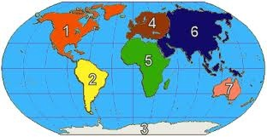
- Name the countries.
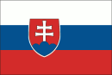 SL_V_K_ _  BR_T_ _N
 the _ S_  G_RM_N_
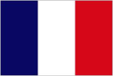 FR_NC_ 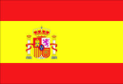 SP_ _ N
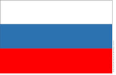 R_SS_ _ 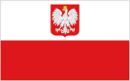 P_L_ND
 _ _STR_ _  C_N_D_
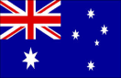 _ _STR_L_ _  GR_ _C_
 H_NG_R_ 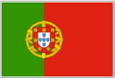 P_RT_G_L
 _T_L_  CH_N_
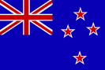 N_W Z_ _L_ND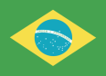 BR_Z_L
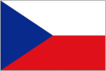CZ_CH R_P_BL_C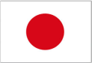 J_P_N
- Discuss. Which of the countries above are European? Where do people speak English? Where are you from?
- ..............................................................
- .............................................................
- ..............................................................
- ..............................................................
- ..............................................................
- ..............................................................
- ..............................................................

- Fill in.
COUNTRY | NATIONALITY
 | Sl_v_k
 | P_l_sh
 | Sp_n_sh
 | _t_l__n
 | Fr_nch
 | Cz_ch
 | R_ss_ _n
 | Br_t_sh
 | _m_r_c_n
 | Br_z_l_ _n
 | _ _str_ _n
 | P_rtg_ _s_
 | Gr_ _k
 | _ _str_l_ _n
 | J_p_n_s_
 | H_ng_r_ _n
 | Ch_n_s_
 | G_rm_n
 | C_n_d_ _n
 | N_w Z_ _l_nd_r

5. Write about your favourite actor, singer, sportsman etc. Example: Peter Sagan is a sportsman. He is from Slovakia. He is Slovak.
.............................................................................................................................................................................................................................................................................................................................................................................................................................................................................................................................................

