PREPOSITIONS IN, ON, UNDER
- Answer.
Where are the children? Where is the cat? Where is the frog?
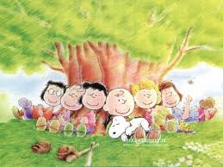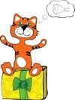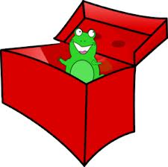
- Fill in. Use prepositions in, on or under.

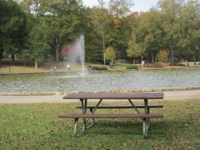
I like going to the park. When I am ... the park, I usually sit ... a bench. The bench is ... the tree. Sometimes I sit ... the grass and listen to the birds; singing ... the trees. When it rains I must walk ... my umbrella. There is also a ... fountain ... the park. The fish ... the water swim very fast.

- Look around the classroom. Where are the things? Draw the picture and write sentences.

..................................................................................................................................................
- Look at the Picture and answer the questions.
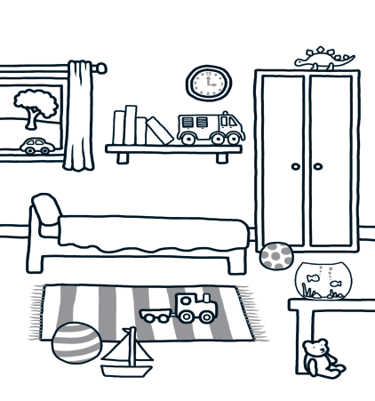
Where is the fishbowl?
..............................................................
Where are the fish?
..............................................................
Where is the car?
..............................................................
Where is the dinosaur?
..............................................................
Where is the bed?
..............................................................
Where is the teddy?
..............................................................
Where are the books?
..............................................................Where is the truck?
..............................................................
Where is the ball?
..............................................................
Where is the boat?
..............................................................

