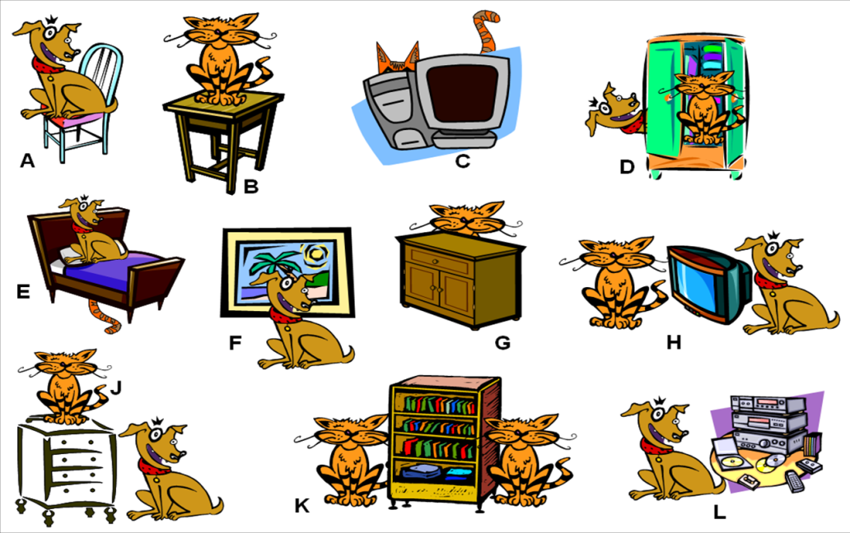
v
na
pod
pred
za
medzi
vedľa
oproti

iN
ON
UNDER
in front of
behind
between
next to
Opposite




- __________________________________________________________________________
- __________________________________________________________________________
- __________________________________________________________________________
- __________________________________________________________________________
- __________________________________________________________________________
- __________________________________________________________________________
- __________________________________________________________________________
- __________________________________________________________________________
- __________________________________________________________________________
- __________________________________________________________________________
- __________________________________________________________________________
- __________________________________________________________________________

