POSSESSIVE ADJECTIVES

- Fill in the table.
Personal pronoun | Possessive adjective
I
you
he
she
it
we
they

- Fill in the gaps.
- I have got a ball. It is ..... ball.
- You have got a plane. It is ..... plane.
- Lucy has got a doll. It is ..... doll.
- Our dog has got a bone. It is ..... bone.
- Peter has got a train. It is ..... train.
- We have got an umbrella. It is ..... umbrella.
- Rosie and Tom have got a book. It is ..... book.

- Complete the sentences.
- I am Ted and this is ..... brothor Sam.
- My friend is Lucy and ..... dog is Black.
- Our parents like ..... jobs.
- The table is wooden. ..... colour is brown.
- We go to school by bus. ..... bus is yellow.
- This is Mark. ..... surname is Smith.
- You have a new T-shirt. I like ..... T-shirt.
- Maria moved house. ..... new address is 6 Green Road.
- You and your sister live in a village. ..... village is small.
- I like watching TV. .....dad watches TV with me.
- We listen to music but ..... friends don’t like it.
- Michael loves ….. mum.
- My cat is noisy. I can hear ..... noise.
- Choose the right word.
I/my am Ron and I/my live in a small town. It/its name is Townsmall. I/my have all I/my friends here. We/our like playing football or cycling. I/my best friend’s name is Peter. Yesterday we/our played football with he/his new ball. It/its colour was black and white. Peter and I go cycling on we/our bikes. I/my bike is blue and he/his bike is red. I/my sister Tina doesn’t like we/our bikes. She/her has got she/her own bike. It/its colour is white. She/her goes cycling with she/her friend Mia. They/their bikes are new but they/their are not fast.
- Look at the pictures. Whose is it?
my dad and .......... computer
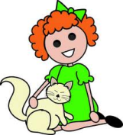 the girl and ................. cat
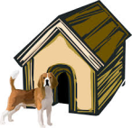 the dog and ................. house
 the family and .............. home
you and ................ ball
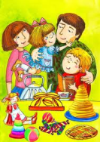 me and ................ family

